Jennifer Stegina

12 September 2019

CIS 250

**Unit 3 Guided Practice 3**

The following questions come from the Task examples in Chapters 9 & 10 in your textbook.

After you are finished, please submit a Microsoft Word file that contains screenshots of the SQL Queries, the output, and put a comment line in the query with your last name. Your document should be named **U3_GuidedPractice3_Lastname.docx**.

(9-2) Question 1:

Create a new table that adds a new column to the *l_foods* table. Create the new column by using a row function that adds together the *price* and the *price_increase* columns. Name this column *new_price*.

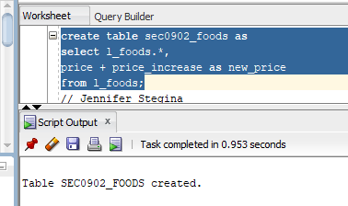

(9-4) Question 2:

From the *l_foods* table list the *menu_item*, *description*, and *new_price*. Calculate the *new_price* by adding together the price and the *price_increase*. List only the foods where the new price is greater than $2.00. Sort the rows of the result table on the *new_price* column.

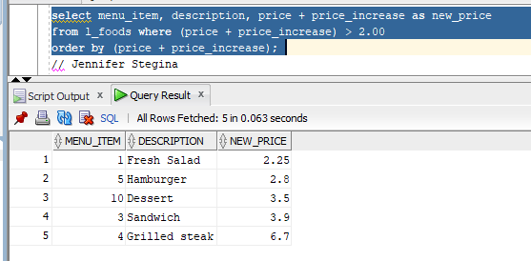

(9-7) Question 3:

Show how to test a row function. As an example, show 3 * 4 = 12.

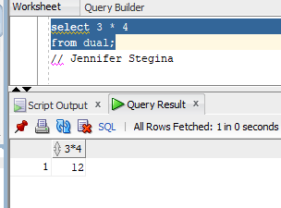

(9-10) Question 4:

List the *employee_id* and the full name of each employee. Create the full name by combining the first and last names separated by a single space.

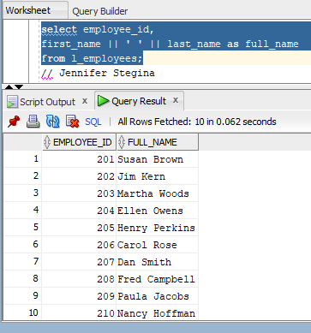

(9-11) Question 5:

The *sec0911_full_name* table contains one column, which contains the full name, both the first name and last name separated by a single space. From this table list the full name, the position of the space, the first name, and the last name.

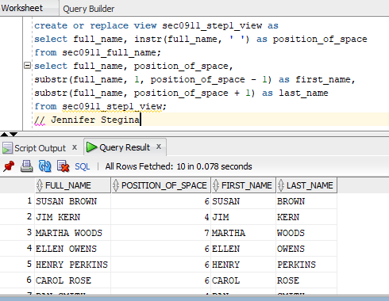

(9-15) Question 6:

List the *l_lunches* table. First, show the times that are in the beginning table. Then show how to remove these times.

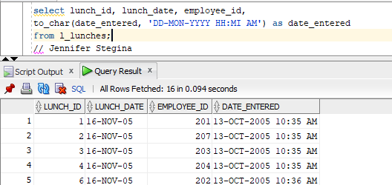

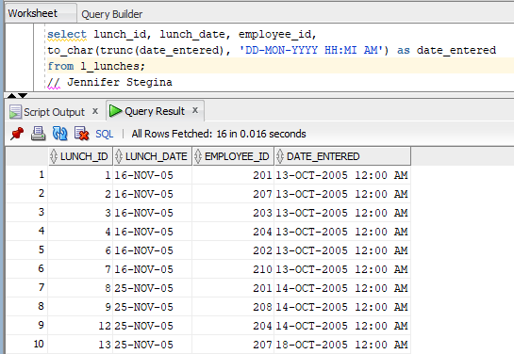

(10-1) Question 7:

Show how to identify the *user*, the *date*, and the *time*.

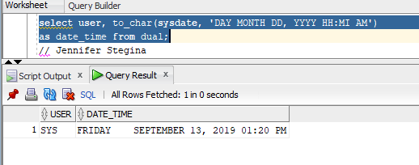

(10-4) Question 8:

Show the effects of automatic datatype conversion. Perform arithmetic on numbers that are in columns with a text datatype.

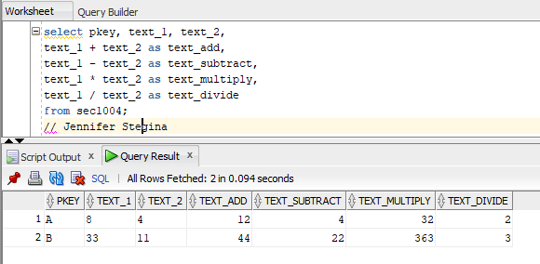

(10-8) Question 9:

List all the numbers that are multiples of three between 50 and 250. To do this, begin with the table *numbers_0_to_99*.

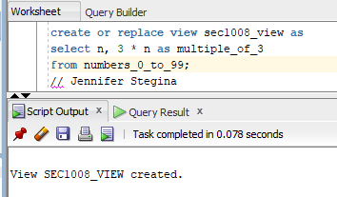

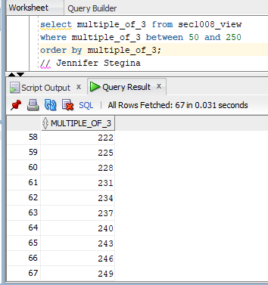

(10-10) Question 10:

List all the days for one week beginning with February 24, 2010. For each date, also list the day of the week in both abbreviated form and fully spelled out.

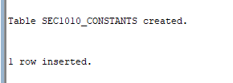



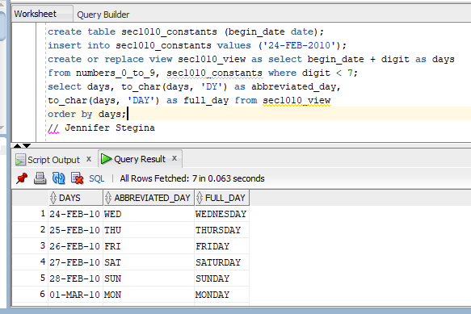

(10-11) Question 11:

Create a calendar showing the workdays, Monday through Friday, for March, April, and May 2015. List the day of the week in one column and the date in the format MM/DD/YYYY in the next column. Leave one blank line between the weeks.

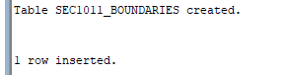

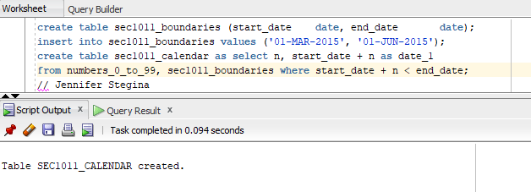

(10-14) Question 12:

The following *select* statement creates a report. All the lines of the report are sorted in a particular order. We want to number the lines of this report sequentially, beginning with 1.

*select price,*

*description*

*from l_foods*

*where price > 1.75*

*order by price,*

*description;*



